## Standard Operating Procedures

**Naming Process for Core sites and Off Grid sites**

**SOP Document Number**: ABMI-MC-SOP-004

**Version Number**: 1.0

**Date**: October 28th, 2015

**Prepared by**: Paola Pierossi and Courtney DesLauriers

**Prepared for**: The ABMI Project

# 

# 

# Approvals

## Version Number 1.0

Approved by: ___________________________ Date: _________________________

(Monitoring Center Director)

### Revision History Log

|  |  |  |  |
| --- | --- | --- | --- |
| Version # | Revision Date | Author | Changes |
| 1.0 | 05/12/2014 | Paola Pierossi | Drafted |
| 1.1 | 28/10/2015 | Courtney DesLauriers | Edited |

Contents

1. Introduction 4

2. Summary of Procedure 4

3. Software Program Requirements 4

4. Core Site Naming Convention- Original Visit 4

Procedure of Naming Core Sites: 5

Division of Responsibility 6

5. Core Site Naming Convention- Revisit 7

Procedure of Naming Core Revisit Sites: 8

Division of Responsibility 9

6. Off Grid Site Naming Convention 9

Procedure of Off Grid Sites: 11

Division of Responsibility 12

# Introduction

The process for naming original core sites and revisit core sites is outlined in this document. Naming revisit core sites was agreed upon by the Monitoring Centre (Kendal Benesh, Dan Greenacre, Courtney DesLauriers, and Nina Veselka), the Information Centre (Shawn Morrison, Ola Pierossi, and Elyse Williams), the Science Centre (MC Roy) and the Royal Alberta Museum (Varina Crisfield, and Robert Hinchliffe). Naming off grid sites was agreed upon by the Monitoring Center (Marty Lankau, Stephanie Ball, Nina Veselka, and Courtney DesLauriers) and the Information Center (Ola Pierossi) starting in 2014.

# Summary of Procedure

Naming ABMI sites requires involvement from the Monitoring, Information, Science and Geospatial centre. Terrestrial sites are spaced throughout Alberta using the 20 km National Forest Inventory (NFI) grid. Terrestrial sites have numerous randomly generated locations surrounding the NFI point within a 10km radius. Wetland sites are selected within a 10km radius of the NFI point based on the selection criteria. Both core sites are named based on the closest NFI point. Off grid sites are named by the Geospatial and Information Centre so that duplication of names does not occur. Revisit sites that are not in the same location as the original visit require a variation of the naming scheme.

# Software Program Requirements

* ArcGIS, Microsoft Excel

# Core Site Naming Convention- Original Visit

Core wetland and terrestrial sites are named based on their proximity to NFI points, ranging from 1 – 1656.

e.g.) NFI 623 🡪 ABMI 623

### Procedure of Naming Core Sites:

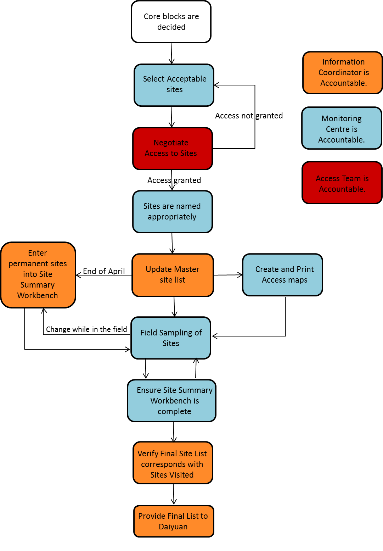

### Division of Responsibility

The Operations Team has representation from the Monitoring Centre, Science Centre, Information Centre and program directives. This team is responsible for selecting each year’s core blocks that will be visited.

The **Monitoring Centre** is responsible for:

* Wetland selection of core sites from the blocks that the Operations Team selected.
* Updating the “UofA_Confidential” GIS layer so the Access team can gain access to our wetland site locations which need to be submitted by **the end of December.**
* If access to the primary site is denied, the access team contacts landowners of terrestrial and wetland alternates. All GIS layers and site envelopes are updated with the new naming convention **by the beginning of the field season.**
* Updating Site Summary Workbench **every 3rd day during shift** with site names and which alternates were visited.

The **Information Centre** is responsible for**:**

* Gaining access to sites and updating the Field Site Record to keep track of alternate terrestrial and wetland sites that will be visited.
* Updating the master site list, ensuring no two sites have the same site name, and tracking revisit sites.
* The Information Coordinator submits the list of site names to the Database Programmer for input into the tablets by **mid-April.**

# Core Site Naming Convention- Revisit

As we revisit core sites, the original site may no longer meet our criteria for site selection and be deemed inappropriate to continue data collection by the Science Centre. Some reasons for no longer visiting a site include: the wetland may have dried up; access may be denied, *et cetera*. As a result, new locations associated with the NFI points are selected. This means that ABMI could have two different sites represented by the same name; the new and old sites require unique identities.

The site names are based on the closest NFI point. In addition, a letter is added as a suffix to indicate that the new location is different from the original. Appending a letter to the site’s core name allows us to maintain the core NFI info:

1. e.g.) Site 63 (original) 🡪 Site 63**B** (new)

If a new location is needed for successive site visits then an alternate location is selected and the corresponding letter progresses through the alphabet.

1. e.g. The third alternate location is required for the revisit to site 63 🡪 Site 63**C** (new)

|  |  |
| --- | --- |
| Alternate | Corresponding Letter |
| Original Visit | N/A |
| 2 | B |
| 3 | C |
| 4 | D |
| 5 | Etc. |

### Procedure of Naming Core Revisit Sites:

### 

### Division of Responsibility

The **Monitoring Centre** is responsible for:

* Identifying wetland sites that no longer fit our site selection criteria throughout the fall season.
* Presenting wetland sites to the Science Centre for the approval of site reselection by **the end of December**.
* Reselecting wetland locations for sites to be surveyed. All GIS layers and site envelopes are updated with the new naming convention **by the beginning of the field season.**
* Updating Site Summary Workbench **every 3rd day during shift** with site names and which alternates were visited.

The **Information Centre** is responsible for**:**

* Gaining access to terrestrial and wetland sites and updating the Field Site Record to keep track of alternate sites that will be visited.
* Ensuring terrestrial alternates are of similar habitat to the original location.
* Updating the master site list, ensuring no two sites have the same site name, and tracking revisit sites.
* Submitting list of site names to the Database Programmer for input into the tablets by **mid- April.**

# Off Grid Site Naming Convention

In order to ensure the off-grid naming strategy is able to survive the life of the ABMI project and prevent naming duplications in the near and distant future, a new naming scheme has been developed by the Information Center.

The goal of this new naming scheme is two-fold; first and foremost to prevent site name duplications in the long-term, by taking away the need to manage the site naming “dash-variables” (-1, -2, -3, etc.) in perpetuity; secondly to associate more information to the site names, which will help in tracking issues that may only become obvious in the distant future.

The new scheme incorporates which NFI point is closest to the site and by associating a sequence of dash-variables to year of implementation, so that for every new field season a new sequence of dash-variables will be used.

e.g.) Terrestrial: OG-ABMI-1183-1 (original) 🡪 OG-ABMI-1183-11 (new)

Wetland: OGW-ABMI-1183-1 (original) 🡪 OGW-ABMI-1183-11 (new)

A master list of sequences is provided below; this list will be used as reference for the naming of all the off-grid sites starting in 2014. The nature of the master list is that it can continue to be populated indefinitely, as need arises.

|  |  |
| --- | --- |
| Year | Dash-variables |
| 2014 | 11-20 |
| 2015 | 21-30 |
| 2016 | 31-40 |
| 2017 | 41-50 |
| 2018 | 51-60 |
| 2019 | 61-70 |
| 2020 | 71-80 |
| 2021 | 81-90 |
| 2022 | 90-100 |
| 2023 | 101-110 |
| 2024 | 111-120 |
| 2025 | 121-130 |

**Site Naming Example:**

Off grid site names are associated with the closest NFI point therefore the first terrestrial off grid site closest to the core site 790 visited in 2014, will be named: **OG-ABMI-790-11**. The second terrestrial site closest to the core site 790 visited in 2014 will be named: **OG-ABMI-790-12** following the same logic applied by the previous naming scheme. However if another site near core site 790 is visited in 2015, it will then be named: **OG-ABMI-790-21**, according to the new sequence of dash-variables associated with 2015.

### Procedure of Naming Off Grid Sites:

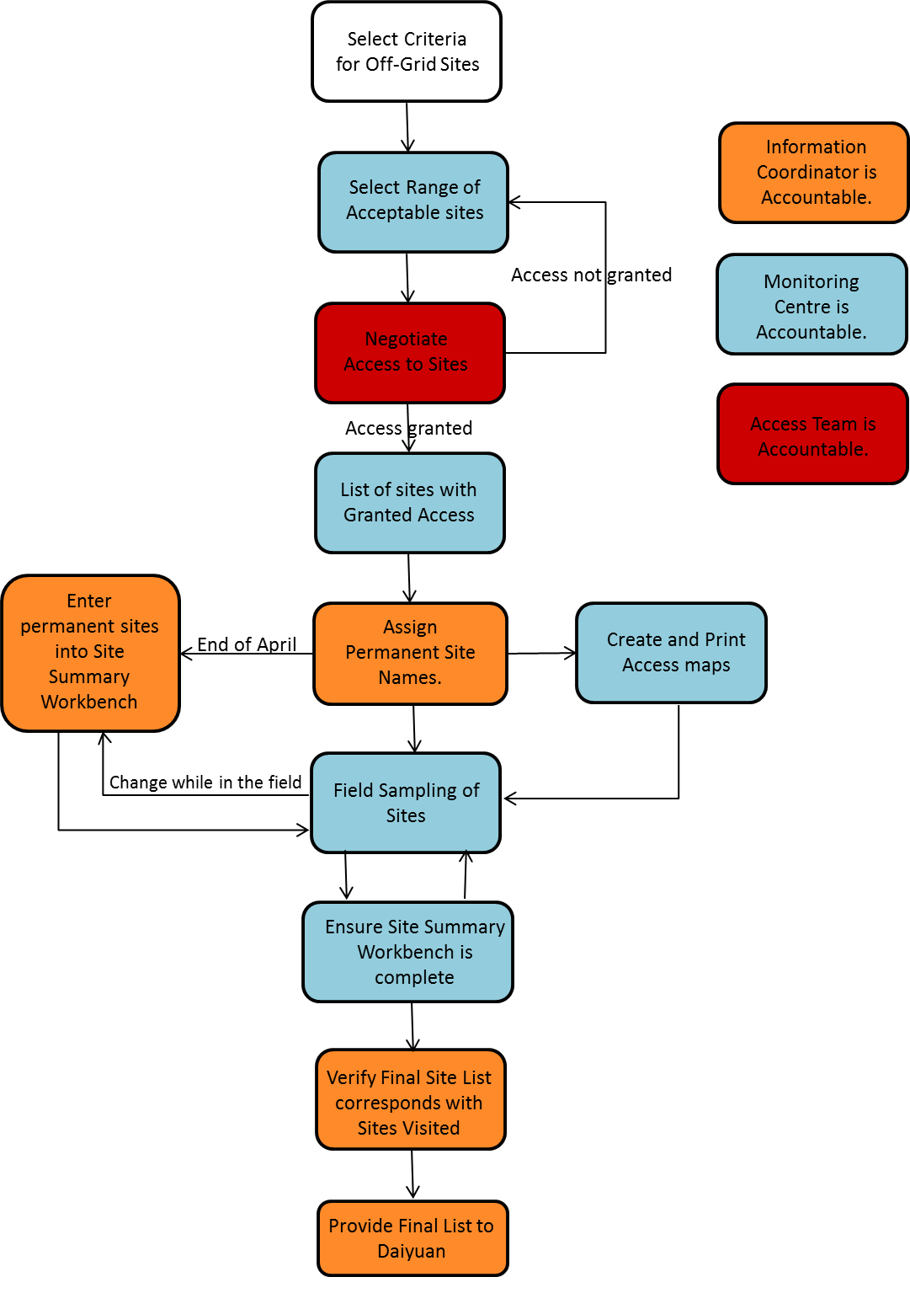

### Division of Responsibility

The Operations Team has representation from the Monitoring Centre, Science Centre, Information Centre and program directives. This team is responsible for deciding how many off grid sites will be completed, what types of disturbances to target, and where in the province they will occur.

The **Monitoring Center** is responsible for:

* Selecting a range of tentative sites based on the criteria provided by the Science Centre
* Negotiating access to the sites in collaboration with the Access team
* Providing the Information Coordinator a “best” list of to-be-visited sites during the field season (including list of possible back-up sites)*
* Managing access-related information
* Updating off-grid site information on Site Summary Workbench of any changes that may occur during the field season
* Having the off-grid site information on the Site Summary Workbench corrected and completed by **beginning of September**

* Although access negotiations may be happening well within the field season, the Monitoring Center has committed to provide the “best” site list to the IC by **middle of March**. This is to ensure all sites with high probability of being visited will receive a permanent name and be recorded on the Site Summary Workbench (SSW) well in advance of the field season start.

The Monitoring Center has also agreed that sites entered into the Site Summary Workbench will not be deleted if access was ultimately not granted or site not visited, instead clear explanations for the lack of data associated to these sites will be recorded in the SSW for future reference.

The **Information Coordinator** is responsible for:

* Providing “permanent”/”official” off-grid names to all the sites included in the Monitoring Centre list with the help from a GIS Technician and by using the public core site layer
* Managing the site naming schema to avoid naming duplications
* Entering the final site list in the SSW
* Providing the Database Manager with the list of sites to add to the tablet
* Verifying the list of off-grid sites is correct and complete at the end of the field season
* Providing the final list of sites to the Geospatial Centre for the generation of maps
* Enter the site names and information in the database

In addition the Information Coordinator will also manage and store additional data associated with off-grid sites in the SSW back-end database. These will be stored in the database, but will not be visible online. The data being stored in association with these sites will include:

1. Original Naming Code*
2. Alternative Naming Code
3. ABMI “permanent” Naming Code*•
4. Nearest Core Site*
5. Latitude*•
6. Longitude*•
7. Year*
8. Data Supplier (Owner)*
9. Natural Region
10. Comments
11. Reason for Selection*

* Denotes a required field

 Denotes data provided by the MC

• Denotes unique fields

 “Reason for selection” is going to be a categorical field, but discussions on the number and types of categories needed are beyond the scope of this agreement and will need to be discussed at a separate time. For the 2014 season this field will not be available and reasons for sites selection will be recorded as free-text in the comments field.